Title Arial Bold 14 pt Centered

Presenting Author¹, Other Author¹, Other Author², Other Author²

¹Affiliation in italic: Group, Institute, University, Address, Code, City, Country

² Second affiliation in italic: Group, Institute, University, Address, Code, City, Country

Abstract

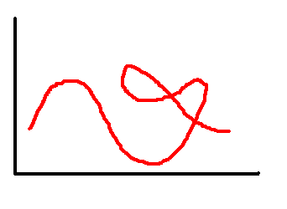
Abstract main body, Times New Roman, 12 pt, paragraphs clearly marked, Abstract main body, Times New Roman, 12, paragraphs clearly marked Abstract main body, Times New Roman, 12, paragraphs clearly marked Abstract main body, Times New Roman, 12, paragraphs clearly marked Abstract main body, Times New Roman, 12, paragraphs clearly marked Abstract main body, Times New Roman, 12, paragraphs clearly marked Abstract main body, Times New Roman, 12, paragraphs clearly marked Abstract main body, Times New Roman, 12, paragraphs clearly marked Abstract main body, Times New Roman, 12, paragraphs clearly marked.
Fig.1. a) Caption of a figure, b) Times New Roman 12 pt.
Abstract main body, Times New Roman, 12, paragraphs clearly marked Abstract main body, Times New Roman, 12, paragraphs clearly marked Abstract main body, Times New Roman, 12, paragraphs clearly marked Abstract main body, Times New Roman, 12, paragraphs clearly marked Abstract main body, Times New Roman, 12, paragraphs clearly marked Abstract main body, Times New Roman, 12, paragraphs clearly marked Abstract main body, Times New Roman, 12, paragraphs clearly marked Abstract main body, Times New Roman, 12, paragraphs clearly marked Abstract main body, Times New Roman, 12, paragraphs clearly marked Abstract main body, Times New Roman, 12, paragraphs clearly marked Abstract main body, Times New Roman, 12, paragraphs clearly marked Abstract main body, Times New Roman, 12, paragraphs clearly marked Abstract main body, Times New Roman, 12, paragraphs clearly marked Abstract main body, Times New Roman, 12, paragraphs clearly marked Abstract main body, Times New Roman, 12, paragraphs clearly marked Abstract main body, Times New Roman, 12, paragraphs clearly marked Abstract main body, Times New Roman, 12, paragraphs clearly marked.

References, Times New Roman 11pt

[1] A. B. Cdefgh, J. Chem. Phys. 6, 334 (1996).
[2] I. Jklmno, P. Rstuw, X. Yzz, Nature 331, 201 (2008).
[3] F. I. Ghlmno, S. E. Rtms: “Title of a book”, City, Publisher (1999), p. 222.

Maximum 1 page A4

