Two-dimensional metal halide perovskite microcrystals: Heterostructures, doping, optical properties and photonic functionality
Martina Borreani¹, Mehrdad Faraji¹, Sudhir Saini¹, Alexander Schleusener¹, Lin-Han Li², Miao-Ling Lin², Ping-Heng Tan², and Roman Krahne¹
¹Optoelectronics Group, Istituto Italiano di Tecnologia, Genova, Italy
²State Key Laboratory of Superlattices and Microstructures, Institute of Semiconductors, Chinese Academy of Sciences, 100083 Beijing, China

Metal-halide perovskites (MHP) emerged as highly interesting materials for photovoltaics and light emission with highly competitive efficiencies.[1] Low-dimensional MHP, where semiconductor octahedra are sandwiched in between organic molecules, feature several highly attractive properties: (i) strong quantum and dielectric confinement, and therefore strongly bound excitons; (ii) a huge parameter space to design their composition, providing an extensive toolbox to tailor their structural, mechanical, and optoelectronic properties.[2] While 2D-MHP thin films have been successfully implemented in LEDs and solar cells, developing high quality single crystals for photonics is another very promising direction. Single crystals allow for a distinct correlation of their optical properties to their structural properties, thereby providing deep insight into their exciton level structure, electron-phonon coupling, and relaxation dynamics. [3-6]
We have developed a microcrystal growth process based on dissolution and recrystallization that allows to fabricate 2D-MHP microcrystals with rectangular shape and highly homogeneous thickness in the few 100 or sub-100 nm range (Fig.1). [7] We demonstrate microcrystal fabrication with different halides, metal cations and organic cations comprising aliphatic chains and aromatic phenyl rings, and on a variety of substrates. The tunable band gap and high refractive index renders such microcrystals extremely promising for photonics and polaritonics.
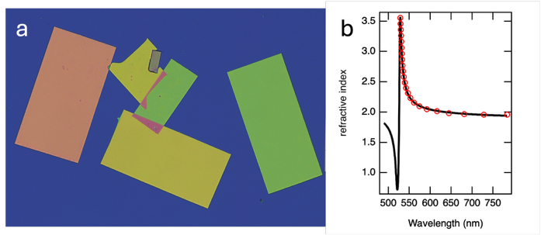
Fig.1. Optical image of 2D perovskite microcrystals (a) and the refractive index dispersion of PEA₂PbI₄ microcrystals (b).
Recently, we extended the microcrystal fabrication to heterostructures, [7, 8] either by solution-based anion exchange, or by sequential growth of different phases (for example with different halides) in a single microcrystal, in core-shell or core frame geometries. With this approach we also managed to fabricate triple halide microcrystals, for example with decreasing band gap from the core to the outer regions.
References
1. H. Dong, et al., eLight, 3,3,(2023).
2. L. Mao, et al., J. Am. Chem. Soc., 141, 1171 (2019).
3. R. Krahne, et al., Nano Lett., 24, 11124 (2024).
4. R. Krahne, et al., Acc. Chem. Res., 57, 2476 (2024).
5. S. Kutkan, et al., Nanoscale, 15,12880 (2023).
6. B. Dhanabalan, et al., Adv. Mater., 33, 2008004 (2021).
7. A. Schleusener, et al., Adv. Mater., 36, 2402924 (2024).
8. A. Griesi, et al., Nanotechn., 35, 105204 (2024).

